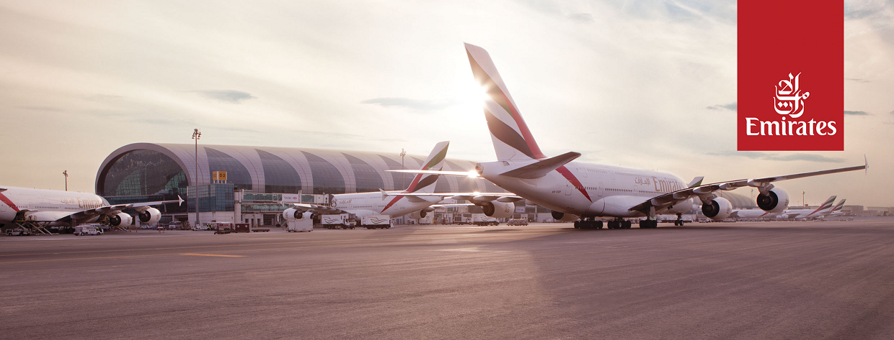
Media fast facts
Emirates fleet
Updated: 13 November 2023

Aircraft type | Current fleet | On order
Airbus A380-800 | 116 | -
Airbus A350-900 | - | 50
Boeing 777-300ER | 123 | -
Boeing 777-200LR | 10 | -
Boeing 777-9 | - | 170
Boeing 777-8 | - | 35
Boeing 787-10 | - | 15
Boeing 787-8 | - | 20
Boeing 777 Freighters | 11 | 5
TOTAL | 260 | 295

Financials - airline
 | 2022-23 (full year results) | 2023-24 (half year results)
Revenue | US$ 29.3 billion | US$ 16.2 billion
Net profit | US$ 2.9 billion | US$ 2.6 billion
Passengers carried | 43.6 million | 26.1 million
Passenger seat factor | 79.5% | 81.5%
Cargo carried (tonnes) | 1.8 million | 1 million
Emirates Public Relations
Email: pr@emirates.com;
Phone: +971 4 708 2145
Media centre: www.emirates.com/mediacentre

